**Requirements Document**

**Individual Project**

**“FC Bayern Munich – Ticketing Service”**

Done by: Stanislav Petkov (4222024)

Class: S3-CB04

Version: 1.0

|  |  |
| --- | --- |
| Version | Changes |
| 0.1 | - Initial version |
| 0.2 | - Functional Requirements removed  - User Stories updated |
| 1.0 | - Project Description added |

**REVISION HISTORY**

Table of Contents

Project Description 4

User Stories 5

Wireframes 11

# Project Description

The purpose of this project is to create an online ticketing system for the football team “FC Bayern Munich”. The service is going to be a web application, where end users will be able to register and browse a catalog with all the upcoming matches of the team, after choosing the match they want to attend, they will be able to select the exact category and block of the stadium they want to book seats for, after that a payment option will be available, which will allow users to purchase tickets and therefore secure their seats. The fans of the club will also have an option to view their booking history, refund their tickets in case of unexpected events and edit their personal information. Furthermore, the financial manager of the club will be able to view various statistics about the sales generated through online ticketing. Also, the administrators of the website will be able to update the schedule with the newest up-coming matches for the team, edit the info of each event in case of an unexpected change or an input error as well as add new teams with their logos to the list of opponents, that can be selected to play against the football club.

All in all, this application will allow the fans of the club to purchase tickets for their favorite football events on reasonable prices while using an easy-to-navigate UI.

# User Stories

|  |  |  |
| --- | --- | --- |
| Title: Category Selection (Booking Step #1) | Priority: MUST | Estimate: 3h |
| **As** a user  **I want** tobe able to choose the category I want to book my tickets in  **so that** I can choose a location and a price of the tickets that’s suitable for me. | | |
| Acceptance criteria:   1. All categories and their prices are displayed. 2. Hovering over the different categories indicates the seats that belong to the currently selected category with red color on the stadium map. 3. When the “select” button is pressed, a message “Are you sure you want to book seats for category [number]?” is displayed. | | |

|  |  |  |
| --- | --- | --- |
| Title: Block Selection  (Booking Step #2) | Priority: MUST | Estimate: 10h+ |
| **As** a user  **I want** tobe able to choose the exact block I want to book tickets for  **so that** I can choose exactly where I want to be, and the best available option based on my opinion**.** | | |
| Acceptance criteria:   1. Only blocks with enough available seats are displayed. 2. After pressing the “select” button, the user gets a message: “Are you sure you want to book tickets for block [number]?”. | | |

|  |  |  |
| --- | --- | --- |
| Title: Booking Tickets - Payment  (Booking Step #3) | Priority: MUST | Estimate: 10h+ |
| **As** a user  **I want** tobe able to purchase tickets for a selected match  **so that** I can book tickets in advance, to make sure I am able to secure tickets for the match I want to watch. | | |
| Acceptance criteria:   1. Total cost and quantity of the tickets is displayed before payment completion. 2. In case the user’s payment details are incorrect, the user gets a warning. 3. In case not all mandatory fields are filled in, the user gets a warning. 4. After successful payment the user gets a confirmation message. 5. After completion the booking is added to the user’s booking history. 6. The booking is added to the system. | | |
| Title: Booking History | Priority: MUST | Estimate: 4h |
| **As** a user  **I want** to be able to check my whole booking history  **so that** I know which matches I have visited and whether I have booked anything in the future. | | |
| Acceptance criteria:   1. All bookings of the user are displayed. 2. In case the user has had no bookings so far, a notification about that is shown. | | |

|  |  |  |
| --- | --- | --- |
| Title: Scheduling a Match | Priority: MUST | Estimate: 10h+ |
| **As** an admin  **I want** tobe able to create new events (matches)  **so that** the site can always provide an up-to-date schedule of the team. | | |
| Acceptance criteria:   1. A warning is shown if any of the mandatory fields are not filled in. 2. A warning is shown if the user picks a date in the past. 3. After completion, a confirmation message is displayed. | | |

|  |  |  |
| --- | --- | --- |
| Title: Editing a Match | Priority: MUST | Estimate: 2h |
| **As** an admin  **I want** tobe able to edit the information about a selected event  **so that** I can fix the event’s information in case of a wrong input or a change of date/time. | | |
| Acceptance criteria:   1. A warning is shown if any of the mandatory fields are not filled in. 2. A warning is shown if the user picks a date in the past. 3. After completion, a confirmation message is displayed. | | |

|  |  |  |
| --- | --- | --- |
| Title: Canceling a Match | Priority: SHOULD | Estimate: 8h |
| **As** an admin  **I want** tobe able to cancel an event  **so that** in case an event gets cancelled due to real-life circumstances, the fans are notified, and the information on the website can be updated. | | |
| Acceptance criteria:   1. A warning “Are you sure you want to cancel this event?” is shown. 2. Each of the purchased tickets is refunded back to the users as a balance in their accounts. 3. Each of the users affected by this cancelation, gets a notification in their inbox. 4. The event is deleted from the system. 5. List of events is updated. 6. Only an event in the future can be cancelled. 7. A confirmation message is displayed after deletion. | | |

|  |  |  |
| --- | --- | --- |
| Title: Adding a Team | Priority: MUST | Estimate: 2h |
| **As** an admin  **I want** tobe able to add new teams to the system  **so that** I can schedule an event with the right opponent the club faces in their next match without any limitations. | | |
| Acceptance criteria:   1. A warning is shown if any of the mandatory fields are not filled in. 2. A warning is shown if a logo has not been uploaded. 3. The team is saved into the system as an option for an opponent. 4. After completion, a confirmation message is displayed. | | |

|  |  |  |
| --- | --- | --- |
| Title: Editing a Team | Priority: MUST | Estimate: 2h |
| **As** an admin  **I want** tobe able to edit every team’s data  **so that** the information about the club’s opponents is always up-to-date and can be fixed in case of initial wrong input. | | |
| Acceptance criteria:   1. A warning is shown if any of the mandatory fields are not filled in. 2. A warning is shown if a logo has not been uploaded. 3. The new team’s data is saved into the system as an option for an opponent. 4. After completion, a confirmation message is displayed. | | |

|  |  |  |
| --- | --- | --- |
| Title: Statistics | Priority: COULD | Estimate: 10h+ |
| **As** a manager  **I want** to view various statistics about the website’s sales  **so that** I can follow the financial situation and act accordingly upon the found results. | | |
| Acceptance criteria:   1. Total money made from sales is displayed. 2. Profit made is displayed. 3. Number of tickets sold is displayed. 4. Statistics for both a single match and all matches combined can be found on the page. | | |

|  |  |  |
| --- | --- | --- |
| Title: Refund | Priority: COULD | Estimate: 4h |
| **As** a user  **I want** to be able to refund my tickets  **so that** in case of an emergency I don’t lose my money. | | |
| Acceptance criteria:   1. Warning saying: “Are you sure you want to refund the selected item?” is displayed when the “refund” button is pressed. 2. The sale of the tickets is removed from the system. 3. The money is given back to the user as balance in his account. 4. The user gets a confirmation message, after the action is done. | | |

|  |  |  |
| --- | --- | --- |
| Title: Registration | Priority: MUST | Estimate: 3h |
| **As** a user  **I want** tobe able to register  **so that** I can gain access to all the website’s features. | | |
| Acceptance criteria:   1. In case of missing fields, the user gets a warning. 2. In case of invalid data (e.g., incorrect email or username already exists), the user is notified. | | |

|  |  |  |
| --- | --- | --- |
| Title: Login | Priority: MUST | Estimate: 2h |
| **As** a user  **I want** tobe able to login  **so that** I can use my account to book tickets and view additional info. | | |
| Acceptance criteria:   1. In case of missing fields, the user gets a warning. 2. In case of invalid login credentials, the user is notified. 3. In case of correct input, a success message is displayed and the user is logged in. | | |

|  |  |  |
| --- | --- | --- |
| Title: Logout | Priority: MUST | Estimate: 1h |
| **As** a user  **I want** tobe able to logout  **so that** I can exit my account when I am not using the website or want to use another profile. | | |
| Acceptance criteria:   1. When the “logout” button is pressed, the user gets a message “Are you sure you want to log out?”. 2. If the user chooses the “Yes” option, he is logged out successfully. 3. If the “No” option is chosen, the user remains on the same page. | | |

|  |  |  |
| --- | --- | --- |
| Title: Password Change | Priority: MUST | Estimate: 1h |
| **As** a user  **I want** tobe able to change my password  **so that** I can make it more secure/easier to remember if I need to. | | |
| Acceptance criteria:   1. In case of missing fields, the user gets a warning. 2. The new password is saved into the system. 3. After completion, the user gets a confirmation message. | | |

|  |  |  |
| --- | --- | --- |
| Title: Filtering | Priority: SHOULD | Estimate: 5h |
| **As** a user  **I want** to have the option to view only matches for a selected month  **so that** I won’t need to look and scroll down in case there are a lot of scheduled matches, this will make planning far ahead easier. | | |
| Acceptance criteria:   1. The user is not allowed to select months in the past. 2. In case there are no scheduled matches for the selected month, the user gets a message. | | |

|  |  |  |
| --- | --- | --- |
| Title: Information | Priority: COULD | Estimate: 2h |
| **As** a user  **I want** to view various information about the website such as their policy and FAQ  **so that** I can stay well-informed and know my rights. | | |
| Acceptance criteria:   1. Links to different topics such as FAQ are displayed on the right side of the home page. | | |

|  |  |  |
| --- | --- | --- |
| Title: Contacts | Priority: MUST | Estimate: 1h |
| **As** a user  **I want** to be able to see a section with a contact info  **so that** I can call/message the support service in case of a problem. | | |
| Acceptance criteria:   1. The “contact info” section is clearly displayed. | | |

# Wireframes

1. Home Page (not logged in)

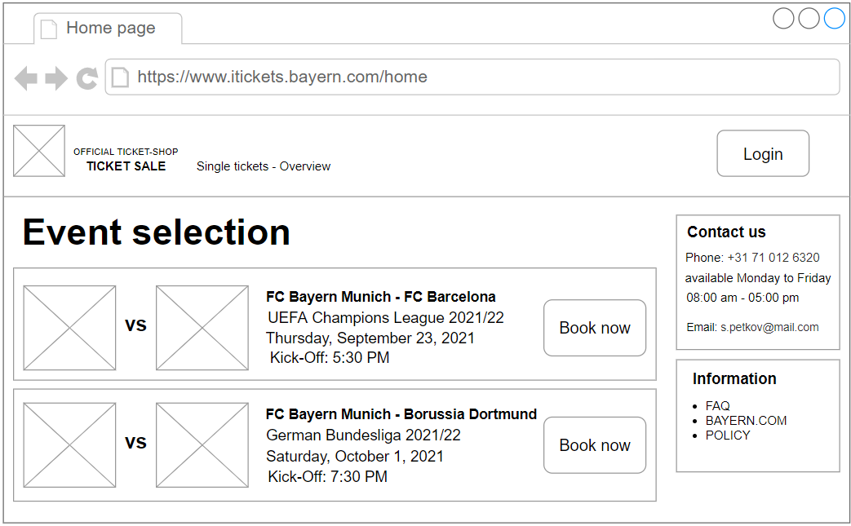

1. Home Page (logged in)

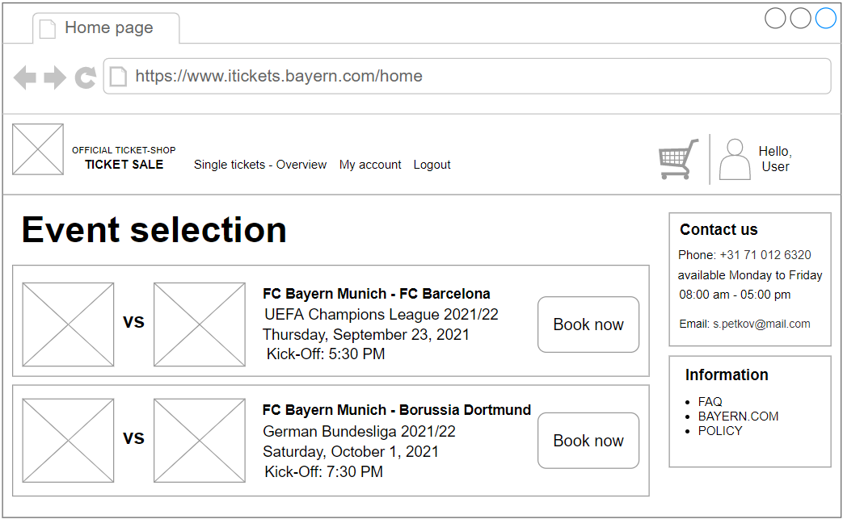

1. Booking – Step #1

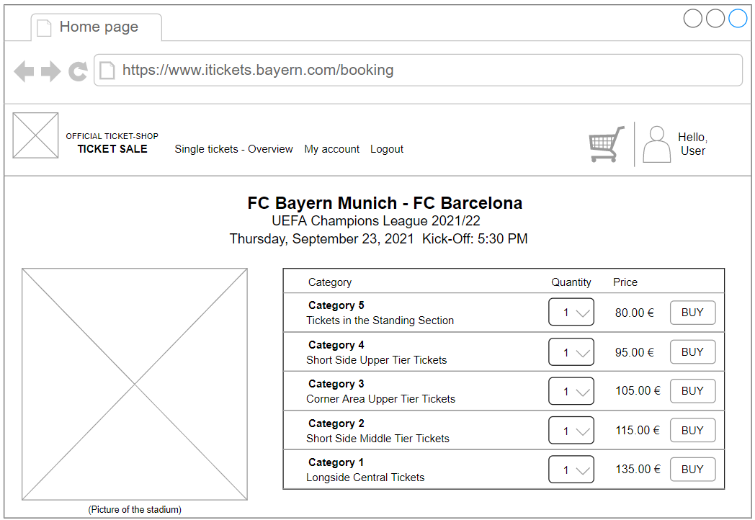

1. Booking – Step #2

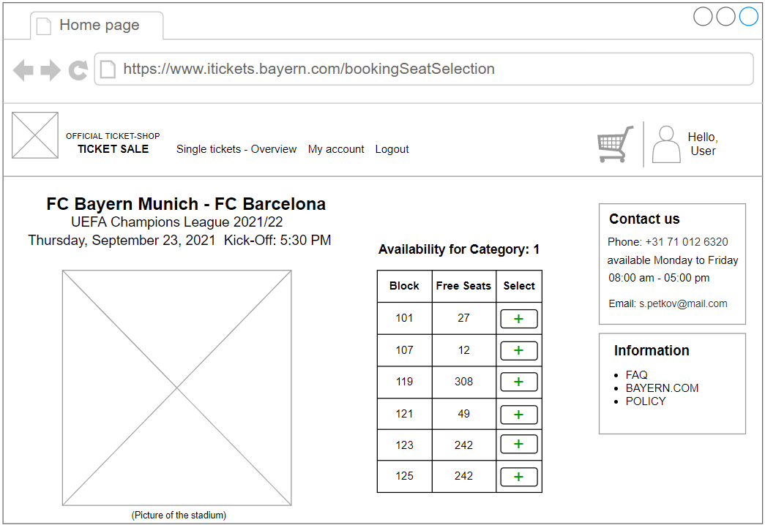

1. Booking – Step #3

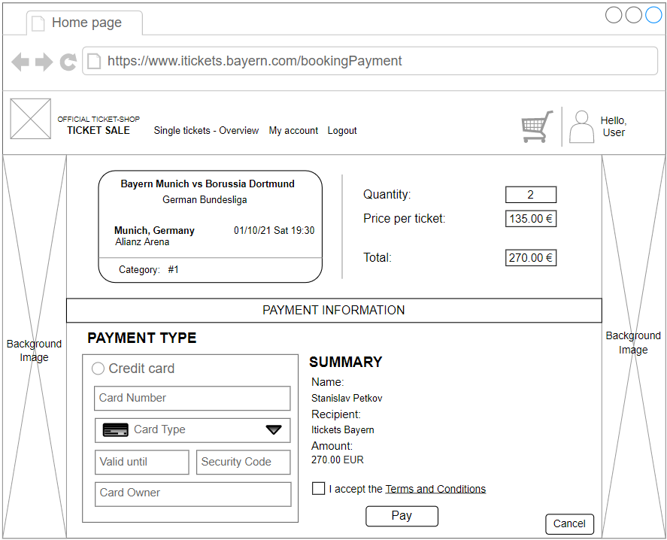

1. Account Page

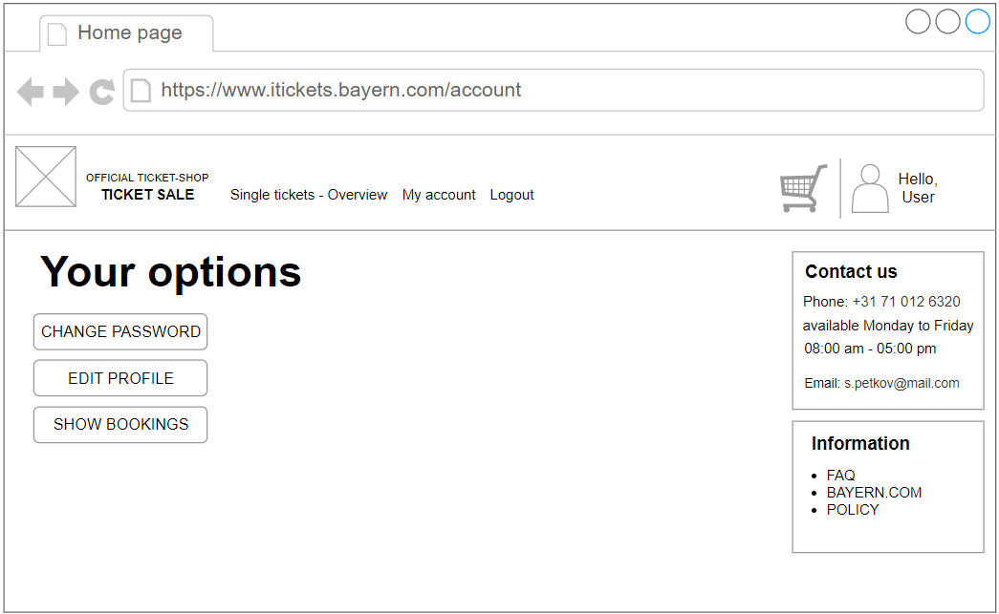

1. Password Change Page

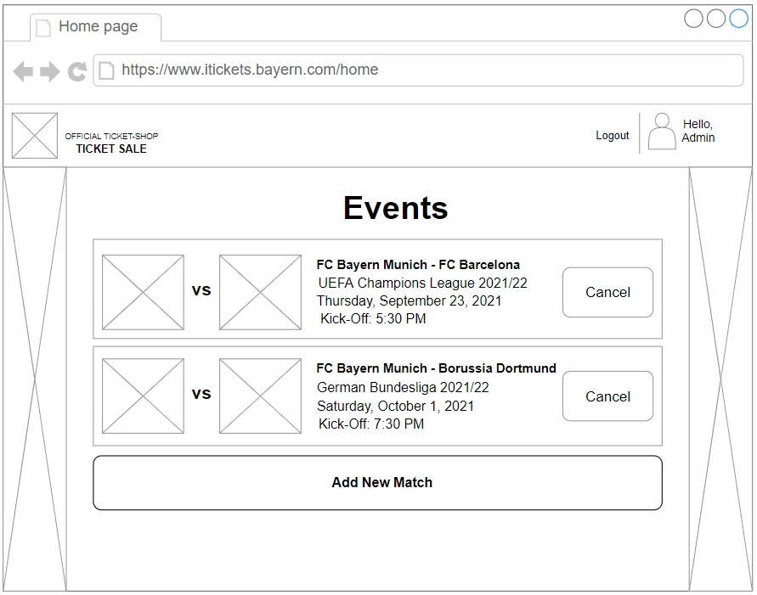

1. Admin Home Page



1. New Event Page

